Amazons

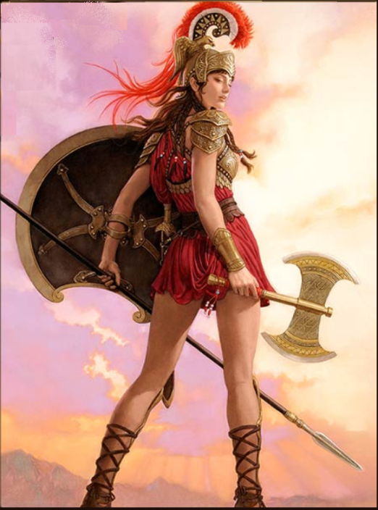

Special Rule: Elite Training
It costs only 1 gold to build the first step for Guardian blocks and only 2 gold to build the first step for Chariot and Bowlyn blocks.

Signature Unit: Medusa
When a Medusa block damages another block in combat, for the rest of the current round of combat, the damaged block's Combat priority becomes D. This ability does not affect castles.

Spells
- Chariot Charge (1): Chariot units are A2 (A3 in desert terrain) for duration of battle.
- The Furies (1): cast 8d6 @ F1. No targeting.
- Vengeance (1): cast 3d6 @ F2. Targeting allowed.
- Heroic Assault (2): all friendly units in Wizard’s hex fire immediately instead of on their normal turn.
- Truestrike (2): cast 3d6 @ F3. Targeting allowed.
- Beguile (3): one targeted Chaos unit switches sides for duration of battle and is then killed.

