Barbarians

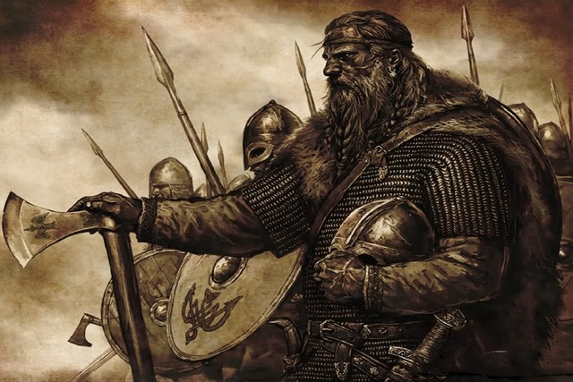

Special Rule: Battlelust
When attacking, at the end of the third combat round, the Barbarian player may decide to force a fourth and final combat round to be fought.

Signature Unit: Berserker
Once a Berserker block is reduced one or more steps in the current combat, its Strength is doubled for the rest of this combat and it cannot retreat (unless forced to retreat at the end of the battle due to participating in a failed attack). This effect persists even if a reduced Berserker block’s steps are fully restored by healing abilities during the combat.

Spells
- Cry Havoc (1): cast 8d6 @ F1. No targeting.
- The Horde (1): add 1 adjacent, friendly unit to this battle; overstacking allowed.
- Berserk (1): cast 2d6 @ F3. Targeting allowed.
- Slash & Burn (2): roll 1d6.
  - 1-4: The Battle hex becomes a Desert hex for duration of Battle.
  - 5-6: No effect.
- Milk & Honey (2): roll 1d6.
  - 1-4: Two hits are restored to friendly units (caster choice).
  - 5-6: No effect.
- Dawn Raid (3): all friendly units in Wizard’s hex fire immediately at +1 Strength (add this bonus after doubling for reduced Berserkers) instead of on their normal turn.

