Dwarves

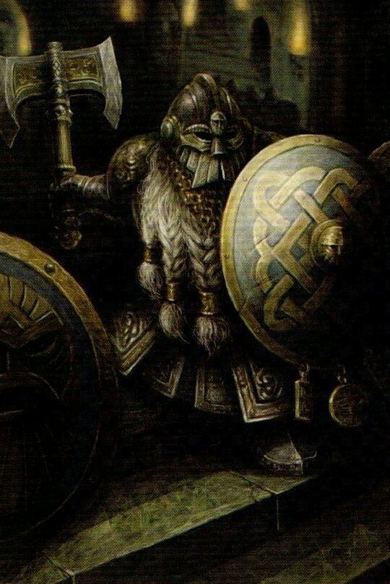

Special Rule: Steadfast
All Dwarven (not including Warbird or Chaos) units have +1 morale.

Signature Unit: High Guard
Whenever a hit is assigned to a High Guard block, roll a die: on a roll of 6 the hit is cancelled.

Spells
- Avalanche (1): cast 8d6 @ F1. Battle hex must have at least one mountain hexside. No targeting.
- Stone Bridge (1): one friendly unit in Wizard’s hex may move like an Amphibian. Cast only in Movement Phase.
- Destruction (1): cast 3d6 @ F3, targeted at Castle unit.
- Hammer of Stone (2): all Dwarven (not including Wizard or Chaos) units in Wizard’s hex are +1 Strength (+1 dice) for duration of battle.
- Stonewall (2): absorbs next three (3) hits on friendly units.
- Dragon Slayer (3): cast 4d6 @ F3. Targeting allowed.

