Feudal

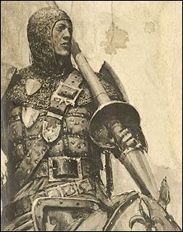

Special Rule: Battle Drill
Once per combat, each Sergeant and Hero block in the combat allow you to re-roll all attack dice or a morale roll for one block with a lower gold cost.

Signature Unit: Knight
In the first round of each combat, each Knight block gets +2 Combat (i.e. each Knight Block is a B4 in the first round of combat).
Spells
- Scouring Light (1): cast 8d6 @ F1. No targeting.
- Foes Begone (1): command 1d3-1 enemy units (caster choice) to retreat.
- Herald (1): any one friendly unit in an adjacent hex may enter the battle immediately and fight normally. Overstacking allowed.
- Crusade (2): all Feudal (not Chaos) units are +1 Strength (+1 die) for duration of this battle.
- Avatar (2): casting Wizard becomes an A3 avatar for this turn and all future turns in this battle, then reverts to normal.
- Wrath of God (3): cast 6d6 @ F3, but only when defending. No targeting.

