Orcs

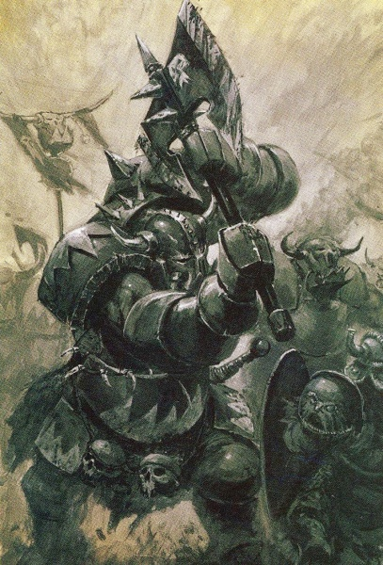

Special Rule: Overwhelm
When attacking, each Orc army block (not Chaos blocks or allies) that was full-strength at the start of the present round of combat gets a “+” added to its Combat (i.e. a Goblin unit that attacks at C1 becomes C+1). This does not affect Shaklas because they are already A+ and B+.
Signature Unit: Troll
At the end of each round of combat, each Troll block that was reduced one or more steps, but not destroyed, rolls a die: on a roll of 5+ the block regains one step (roll this die prior to rolling for morale).

Spells
- Fireball (1): cast 4d6 @ F2. No targeting.
- Troll-Tracks (1): one friendly unit Wizard’s hex may move like an Amphibian. Cast only in Movement Phase.
- Panic (1): roll 1d6.
  - 1-4: Retreat one enemy unit (caster’s choice).
  - 5-6: No effect.
- Fire Arrow (2): cast 3d6 @ F3. Targeting allowed.
- Swarm (2): all friendly units in Wizard’s hex fire immediately instead of on their normal turn.
- Flame-Strike (3): cast 8d6 @ F2. No targeting.

