Undead

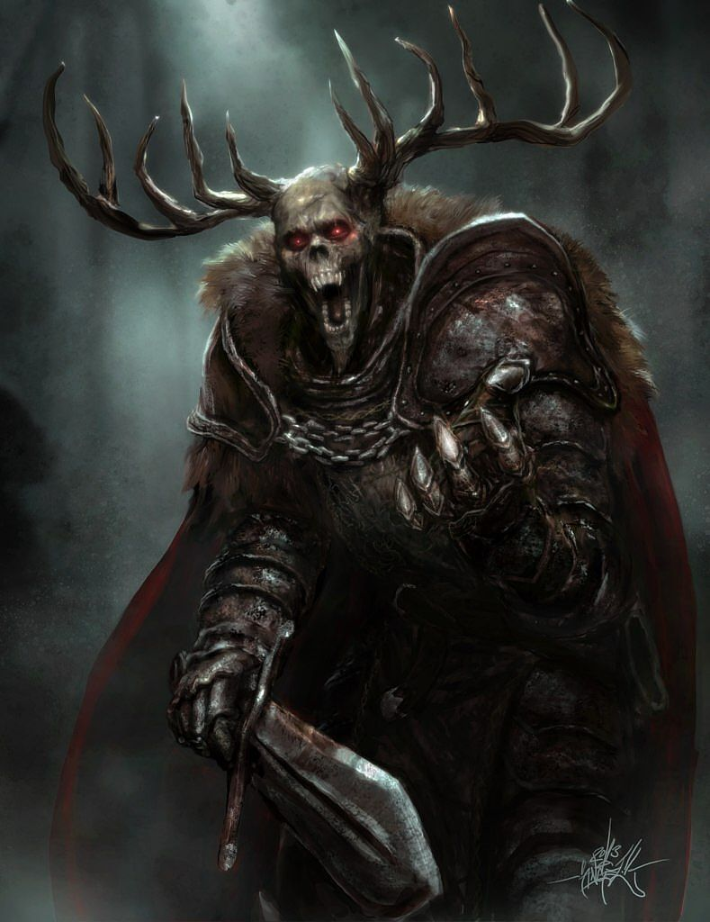

Special Rule: Relentless Advance
Instead of retreating, when Undead (not Chaos) units fail a morale test they lose one step. The normal morale modifiers do not apply. However, Undead blocks do get +1 morale for each Summoner taking part in the battle (Summoners are: Necroms, Heroes, and Vampires). A roll of 6 always fails. Summoners are not affected by morale.

Signature Unit: Vhargan
At the start of combat, for each Vhargan block participating in the battle, you may nominate one enemy unit to get -1 Strength and Morale (no block's strength or morale may be reduced to less than one using this rule).

Spells
- Corpse Harvest (1): Cast only during battle. Add D3 steps to Zombie blocks participating in this battle or summon a new Zombie block with D3 steps (must choose one option before rolling the die).
- Dread Howl (1): roll 1d6.
  - 1-4: Retreat 1 enemy unit (caster choice).
  - 5-6: No effect.
- Death’s Hand (1): cast 2d6 @ F3. Targeting allowed.
- Plague (1): cast 4d6 @ F2. No targeting.
- Living Shadows (2): cast 3d6 @ F3. Targeting allowed.
- Summon (2): brings one unengaged friendly unit to Wizard’s hex. This unit may overstack in a battle and fight normally.
- Dark Sacrifice (3): cast 4d6 @ F3 targeted on one enemy unit. If targeted unit is eliminated, Wizard gains +1 strength.

